A000-Mex-Colima-Standing Figure, female-Turban-Arm band-Terra cotta-300 BCE-300 CE

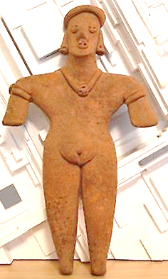

Mex-Colima-Standing Figure, female-Turban-Arm band-Terra cotta-300 BCE-300 CE

**Case No.: 9**

**Accession No.**

**Formal Label:**

**Display Description:**

Large Standing Pre-Columbian Colima Figure, female. Distinctive turban style headdress, ear spools, a necklace, Distinctive treatment and modeling of the eyes, mouth and hands. Originally deposited in a shaft tomb.

* **LC Classification: F1219.1.C75**

**Date or Time Horizon:**

**Geographical Area:**

**Map:**

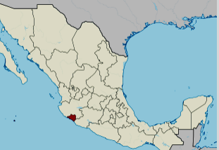

**Location of Colima, Mexico. https://upload.wikimedia.org/wikipedia/commons/thumb/a/a6/Colima_in_Mexico_%28location_map_scheme%29.svg/375px-Colima_in_Mexico_%28location_map_scheme%29.svg.png**

**GPS coordinates:** [19°10′N 103°53′W](https://tools.wmflabs.org/geohack/geohack.php?pagename=Colima&params=19_10_N_103_53_W_type:adm1st_region:MX)

**Cultural Affiliation:**

**Media:**

**Dimensions:** 6" high

**Weight:**

**Condition:**

**Provenance:** Originally deposited in a shaft tomb. Recovered from the ancient Colima culture in Western Mexico prior to 1970.

**Discussion:**

The Los Ortices period (500-300 BCE) established elements of the Colima culture, including shaft tombs and a distinctive ceramic style called *rojo bruñido,* or burnished red. The following Comala or Colima culture developed at the Comala site (300-300 CE). The Colima people perfected burnished red pottery *rojo bruñido* and produced terra cotta figurines of people and animals with distinctive fluid lines. The Comala site shows influence from Teotihuacan. Around 500 CE, another site in Armería developed along the river of the same name.

**References:**

Reynolds, Richard D. 1993. *The Ancient Art of Colima, Mexico*. Walnut Creek, Calif.: Squibob Press.